Doña Ana County Humane Society, Inc.
FY 2019-20
Annual Report
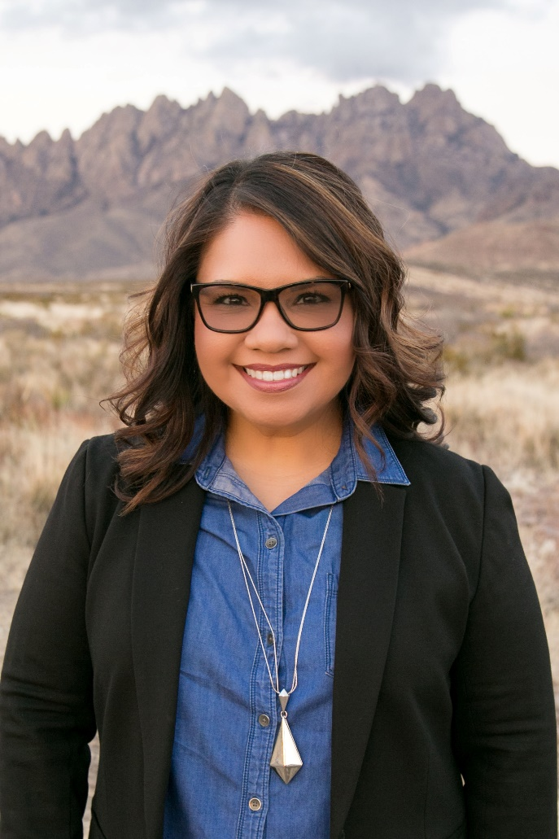
The Doña Ana County Humane Society is the area’s oldest animal welfare organization, with a long history and a modern outlook on helping pets and their people in our community.
April T. Anaya replaced Kathy Lawitz as executive director of the Doña Ana County Humane Society on Nov. 1, 2019.
We are a 501(c)3 organization. We founded Las Cruces’ first-ever animal shelter in 1955, and operated the facility for many years. Many remember us as the shelter out on Hwy. 70, which was called the Doña Ana County Humane Society. It changed hands in 2008 when DACHS opted not to renew the contract to run the shelter for the city/county. They hired their own director and changed the name of the facility to the Animal Service Center of the Mesilla Valley (ASCMV.)
Today, DACHS continues to operate as a 501(c)3 non-profit organization and we still support the shelter. But rather than operating a facility, our focus now is to simply save the lives of animals.
We do that by administering programs that help get pets out of the shelter, into good homes, and keep them out of the shelter. Our motto is “Keeping People and Pets Together.”
To that end, we address problems on multiple fronts, utilizing methods that have potential for making the greatest impact. We do not duplicate services provided by other animal welfare organizations, but fill areas of unaddressed need.
DACHS’ mission is to serve as an advocate for the animals and their people in Dona Ana County and to maintain an environment of respect, responsibility and compassion through education, legislation and leadership. We are committed to reducing animal overpopulation and defending the abused. Here are the programs we operate toward those goals:
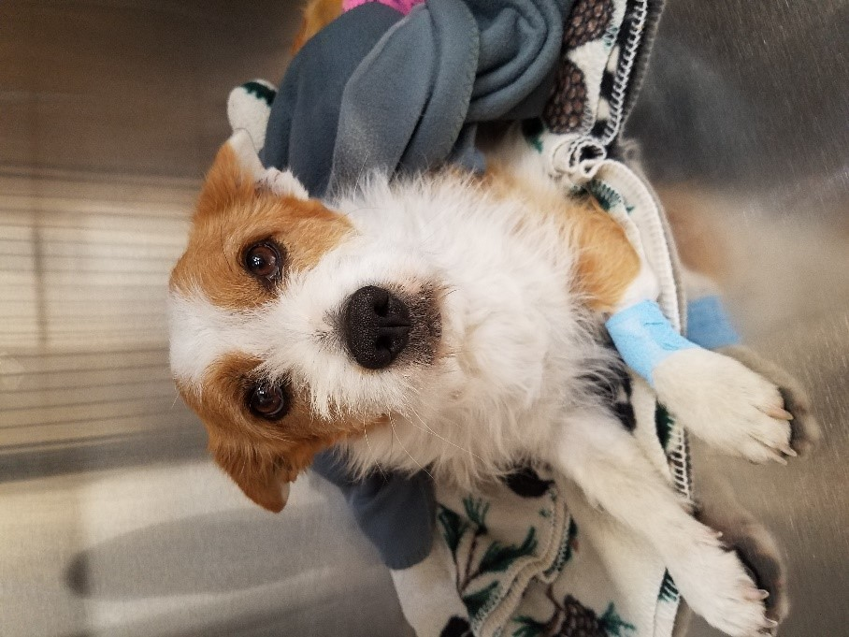
Animal Relief Fund (ARF): This program aids low- income pet owners with emergency, quality-of-life and preventive veterinary bills, as well as prescription food and medications. All cases must meet HUD income eligibility guidelines with proof of household income. Once approved, clients pay a $50 co-pay to DACHS and in return receive a $250 voucher that they can use at one of the participating veterinary offices in the county. If the bill is higher than the voucher amount, the client can purchase a second voucher for an additional $50. The problem cannot be due to something that was preventable, such as pregnancy, parvo, rabies, or distemper.
We opted to change the prescription medication voucher rules this year due to rising costs that were compromising our ability to help as many animals as possible. In years prior, no co-pay was required to receive a voucher that covered six months of prescription food/medication, and there was no cap on how much we covered. Starting Jan. 1, 2020, qualifying recipients will pay $50 in order to receive a voucher, which will cover up to $750 in prescription medications/food during that six-month period.
Sausage escaped his home and was hit by a car, which resulted in a leg fracture that his owner could not afford to have fixed. They were able to get veterinary aid through the Animal Relief Fund and today, Sausage is running on all fours.
The veterinary clinics we work with are: Animal Hospital of Las Cruces, Arroyo Veterinary Clinic, Calista Animal Hospital, East Lohman Veterinary Clinic, Jornada Veterinary Clinic, Mesquite Animal Hospital, Paisano Animal Clinic, Southwest Animal Care Complex and Dr. William J. Schumacher, DVM.
Operated by DACHS when we ran the shelter, the ARF program was shelved when the shelter contract ended. Since the program was reinstated in September 2010, ARF has helped more than 1,900 low-income pet owners. The program’s fiscal year 2019-20 budget is $82,250, slightly lower than the prior fiscal year, but far higher than the $12,500 budget we started with in 2010. In addition to money from our invested corpus, ARF is supported by donations, grants and fundraisers, including a second-time grant this year from PetSmart Charities. We are fortunate to have received grants for seven years from Banfield Charitable Trust/Banfield Foundation, as well as grants from the ASPCA, Athletes for Animals, Bissell Foundation and BNSF.
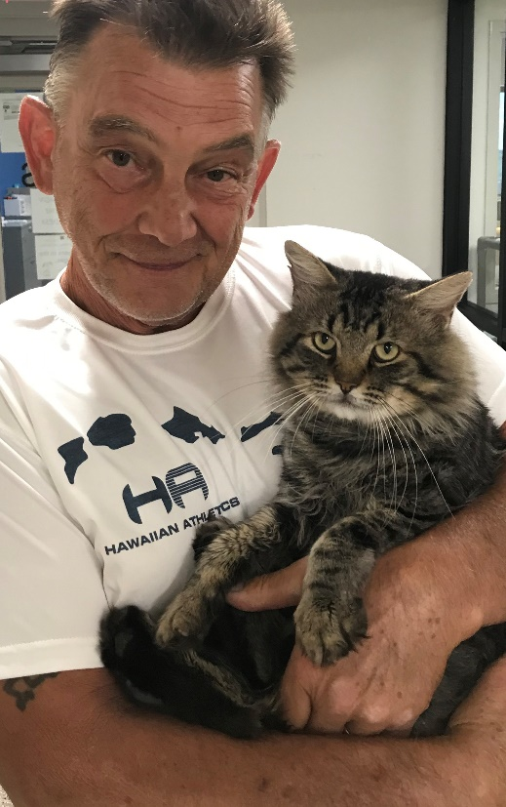
Pets for Seniors: This program provides vouchers that waive the cost of adopting a shelter pet for seniors age 60 and older. The purpose is to help alleviate the loneliness that seniors often suffer, and place shelter pets in stable, forever homes. With a Pets for Seniors voucher, ASCMV’s $25 adoption fee is waived and the pets are free. This program was operated by DACHS when we ran the shelter and it went away after the shelter contract ended. We revived the program in February 2011. The program is funded by the Pets for the Elderly Foundation and we have allocated $4,000 for it in the 2019-20 budget. We have issued nearly 1,000 Pets for Seniors vouchers since we reintroduced the program.
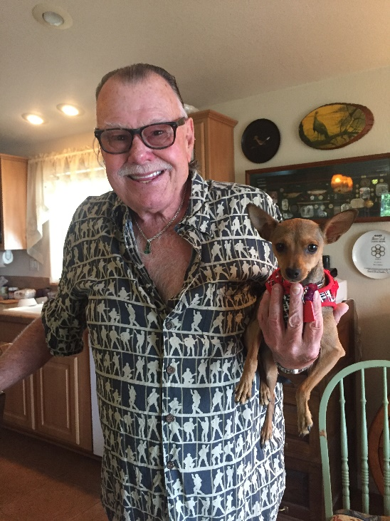
Ruff-to-Ready Program: This program offers training to shelter dogs as they go into their new adoptive homes so that they won’t be returned to the shelter for behavioral issues. DACHS ran a pilot of the program in May 2012, with $1,000 in grant funding from the Allstate Foundation. With that funding, we hired a dogs they were either fostering or adopting from the ASCMV. This trainer also worked with the adoptive family members and other dogs in the families. She evaluated the dogs’ behavior and their home situations, and worked with both the dogs and their owners/fosters on basic commands and on correcting problem behavior. The group was monitored for six months to see if any dogs were returned to the shelter, and none of them were. That trainer left and was replaced by Hope Movsesian, who to date has worked with nearly 240 dogs and their owners. She provides the same type of training: two free in-home sessions, working with the family and other animals in the household, and she goes the extra mile by providing additional resources such as informational sheets and web links. We have allocated $5,000 for the Ruff-to-Ready program for the current fiscal year. That is down from the previous two years, as the program wasn’t utilizing all of its funding. Ruff to Ready was expanded several years ago to include dogs that people are trying to surrender to the shelter for behavior problems.
Mr. Vancott adopted Moro from the Animal Services Center of the Mesilla Valley through the Pets for Seniors program.
Charles Sparks received training for his shelter dog, Ruby, through the Ruff-to-Ready dog-training program.
Other projects
A Home for the Holidays: This is a free pet adoption event that is held the weekend prior to Christmas, with the goal of getting as many pets as possible out of the Animal Services Center of the Mesilla Valley and into permanent homes in time for the Christmas holiday. The program is going into its ninth year after a successful 2018 event, in which 78 shelter pets were adopted. This year, pet adoption fees at the ASCMV have been permanently dropped to $25 per animal, so we can cover more adoptions with the program’s $2,500 budget. We fund “A Home for the Holidays” through our corpus and through donations.
Pet cemetery: The Alicia Melgaard Memorial Pet Cemetery, which DACHS owned since the mid-1980s, was sold to a private party earlier this year and now operates as the Zen Pet Cemetery. The cemetery was more a community service than an income stream, which we need to sustain our programs for the living.
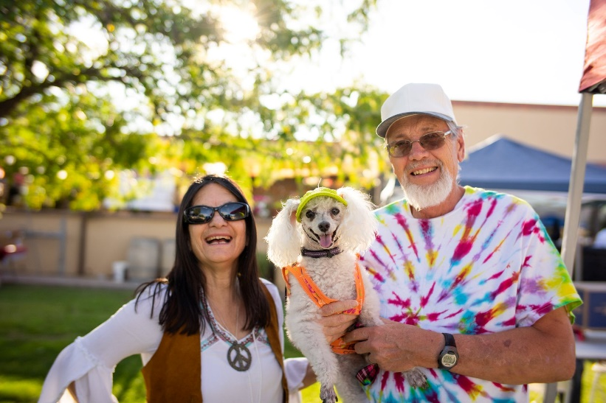
Yappy Hour: DACHS has been the main organizer of Yappy Hour since it was reinstated in 2011 after a hiatus when DACHS opted out of the shelter contract. We first held it at Andele’s Dog House in Mesilla, but quickly outgrew that venue and moved to D.H. Lescombes Winery & Bistro, which has an expansive grass lawn and outdoor patio that accommodates any size crowd. The event continues to grow in size and popularity. It receives in-kind advertising from Better Life Pet Foods, BravoMic Communications, DogCruces, Enchanted Occasions Event Rentals and other supporters who help sponsor the Caliche’s Custard Wagon at Yappy Hour. Each month has a theme, and the two most popular ones in 2019 were “Woof-stock” in August and “Halloween” in October. The event benefits both DACHS and the Spay/Neuter Action Program (SNAP.)
Kathy and Steve Peerman with their pooch at
"Woof-stock" Yappy Hour.

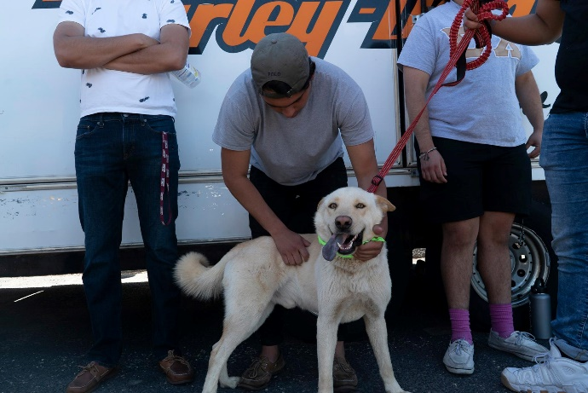
Paws ‘n Claws Road Rally: DACHS held its sixth annual Paws ‘n Claws Road Rally fund-raiser in April. This event’s goal is to attract a different crowd, pulling from car and motorcycle enthusiasts. It features a ride around the around the city and a party afterward. Adoptable dogs from the Animal Services Center are on display during check-in time at Barnett’s Harley-Davidson, with an after-party at a local venue. This event has been supported for two years by a City of Las Cruces special events grant.
NMSU fraternity brothers help with a shelter dog available for adoption at the 2019 Paws 'n Claws Road Rally.

FINANCES
Our FY 2019-20 budget includes program expenses and general expenses such as the lease that we share with SNAP for our office space, insurance, alarm system, accountant & bookkeeper, and the salary of the executive director, a contract position.
The FY 2019-20 budget is approximately $4,000 larger than the last fiscal year budget.
Costs that dropped off (but are not yet reflected on the FY 2019-20 budget) are cemetery insurance, maintenance and materials.
Costs that decreased include accountant (we were able to save by providing available materials necessary for our 990 early), office equipment repair (we bought a new computer in the last fiscal year), office supplies, and chamber membership dues and sponsorships.
Costs that rose include liability/property insurance, which has nearly doubled (not reflected yet on the current budget) because our carrier quit providing coverage for organizations that deal with animals and our insurance broker could find only one other, far more expensive, option.
We added a $1,000 storage shed/shred line item to the current budget so we could hire American Document Services to shred boxes of old records that were stored in the cemetery shed when the property sold.
Our cable/internet/phone costs grew slightly, but after adjustments were made to the bundle earlier this year, this line item should be less next fiscal year.
The executive director got a slight pay increase in order to continue bringing her salary into the competitive salary range for that position.
We continue to contract with a marketing company to help raise our social media presence and help separate us from the shelter, as some of the public still believes we run the shelter on Hwy. 70. The company also manages our website and social media, and has been key in attracting new faces to our events.
On the income side, we just received approval for a $52,500 grant from PetSmart Charities for the Animal Relief Fund and its related expenses. We also received a grant $7,500 grant from Banfield Charities for ARF, and nearly $3,000 to date this fiscal year from the Pets for the Elderly Foundation for the Pets for Seniors program.
We also received a generous donation from Bill and Hannah Monsimer, who gave to our Community Foundation endowed fund during a 150-percent match-grant period, resulting in an increase of $58,000 in new funding in our account.
Our total invested corpus with Morgan Stanley Smith Barney is $530,339 as of December 3, 2019, down by approximately $82,921 from this time last fiscal year. This fiscal year we drew out $40,000 for operating expenses and an additional $66,000 for the ARF and Ruff-to-Ready programs, as part of our invested bequest money is donor-advised for the care of animals only.
Some of this invested money came with us when we ended the shelter contract several years ago. It is comprised of bequests and donations to DACHS, not to the city or county. Some of it is reimbursement that the city and county agreed that they owed DACHS for operating expenses incurred while under contract to operate the shelter: just under $109,000 from the county and $160,000 from the city. The fund is set up fairly conservatively as a long-term investment with the idea that the market fluctuates but will recover.
We set up the fund this way so that proceeds are automatically reinvested, and we keep a portion of it - 10 percent - in a cash account at Morgan Stanley so that we have operating funds to draw from when needed.
We transferred $65,000 from the account in FY 2010-2011 to help fund our programs and operations. In the FY 2012-13, we transferred $47,500 to help fund our programs and operations; $58,872 in FY 2014-15, $30,000 in FY 2015-16, $25,000 in FY 2017-18, $63,000 in FY 2018-19, and a total of $40,000 so far in FY 2019-20.
Of the $65,000 withdrawn in 2010-11, $35,000 was paid out as grants and donations to other animal welfare organizations and the other $30,000 was used for operating expenses. In 2011-12, $29,500 of the $47,500 withdrawn was paid out as grants and donations to other animal welfare organizations, including $6,000 to the newly formed Coalition for Pets and People. The remainder went toward programs and operating expenses. Going forward from 2013, we decided that we need to focus on funding our own growing programs and discontinued grants to other organizations.

Our board has discussed this investment fund at length. Our goal is to protect the corpus so that we can continue to operate for the long term and focus on fund-raising via events, memberships, donations and grants to offset the cost of our programs and operating expenses, and keep the investment fund growing so that we can continue to do good work in our community.

Doña Ana County Humane Society, Inc.
Board of Directors
Officers
Teryl Beck, president
Willie Apodaca-Fisk, vice president
Alisha Munn, secretary
Cristie Stuart, treasurer

Board Members
Robert Moreno
Sherri Rials
Janice Shifflet

Executive Director
April T. Anaya

